Database name : db_top_rate_school

Tự động reset Database sau mỗi lần khởi động chương trình :

spring.jpa.hibernate.ddl-auto=create

Data (table) mặc định :

Students

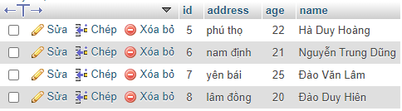

Courses

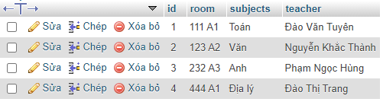

Students_courses

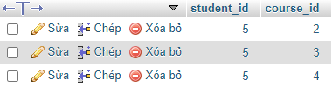

1 . API lấy danh sách lớp :

URL : <http://localhost:8081/courses/list>

MENTHOD : GET

BODY RESPONSE :

[

    {

        "id": 1,

        "subjects": "Toán",

        "room": "111 A1",

        "teacher": "Đào Văn Tuyên",

        "students": []

    },

    {

        "id": 2,

        "subjects": "Văn",

        "room": "123 A2",

        "teacher": "Nguyễn Khắc Thành",

        "students": [

            {

                "id": 5,

                "name": "Hà Duy Hoàng",

                "address": "phú thọ",

                "age": 22

            }

        ]

    },

    {

        "id": 3,

        "subjects": "Anh",

        "room": "232 A3",

        "teacher": "Phạm Ngọc Hùng",

        "students": [

            {

                "id": 5,

                "name": "Hà Duy Hoàng",

                "address": "phú thọ",

                "age": 22

            }

        ]

    },

    {

        "id": 4,

        "subjects": "Địa lý",

        "room": "444 A1",

        "teacher": "Đào Thị Trang",

        "students": [

            {

                "id": 5,

                "name": "Hà Duy Hoàng",

                "address": "phú thọ",

                "age": 22

            }

        ]

    }

]

2 . API lấy danh sách học sinh của lớp học :

URL : http://localhost:8081/course/2

MENTHOD : GET

BODY RESPONSE :

{

    "id": 2,

    "subjects": "Văn",

    "room": "123 A2",

    "teacher": "Nguyễn Khắc Thành",

    "students": [

        {

            "id": 5,

            "name": "Hà Duy Hoàng",

            "address": "phú thọ",

            "age": 22

        }

    ]

}

3 . API đăng ký lớp học :

URL : http://localhost:8081/student/registration?student_id=6&course_id=4

MENTHOD : POST

BODY RESPONSE :

{

    "id": 6,

    "name": "Nguyễn Trung Dũng",

    "address": "nam định",

    "age": 21,

    "courses": [

        {

            "id": 4,

            "subjects": "Địa lý",

            "room": "444 A1",

            "teacher": "Đào Thị Trang"

        }

    ]

}

Database sau khi thực hiện đăng ký : bảng Students_courses thay đổi (thêm)

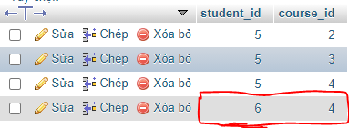

4 . API cập nhật lớp học :

URL : http://localhost:8081/student/update_courses

MENTHOD : POST

HEADER REQUEST : content-type: application/json

BODY REQUEST: ( chỉ cần trường id các trường khác không có cũng được – như trường name bên dưới không đổi dù có giá trị gì)

{

    "id": 5,

    "name": "Hà Duy Hoàngdsfs",

    "address": "phú thọ",

    "age": 22,

    "courses": [

        {

            "id": 4,

            "subjects": "Địa lý",

            "room": "444 A1",

            "teacher": "Đào Thị Trang"

        },

        {

            "id": 1,

            "subjects": "Toán",

            "room": "111 A1",

            "teacher": "Đào Văn Tuyên"

        }

    ]

}

RESPONSE BODY :

{

    "id": 5,

    "name": "Hà Duy Hoàng",

    "address": "phú thọ",

    "age": 22,

    "courses": [

        {

            "id": 4,

            "subjects": "Địa lý",

            "room": "444 A1",

            "teacher": "Đào Thị Trang"

        },

        {

            "id": 1,

            "subjects": "Toán",

            "room": "111 A1",

            "teacher": "Đào Văn Tuyên"

        }

    ]

}

Database sau khi thực hiện update lớp học : bảng Students_courses thay đổi (update) :

